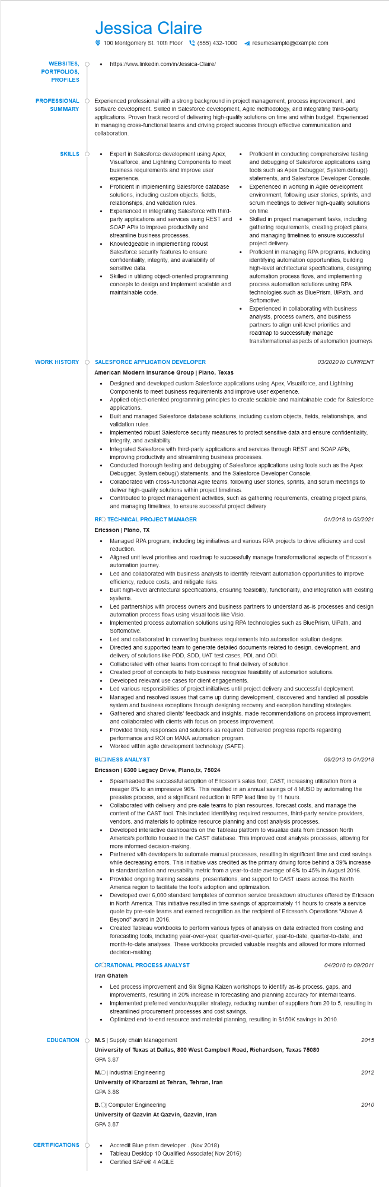
WEBSITES, PORTFOLIOS, PROFILES
Jessica Claire
100 Montgomery St. 10th Floor (555) 432-1000
https://www.linkedin.com/in/Jessica-Claire/
resumesample@example.com
PROFESSIONAL SUMMARY
Experienced professional with a strong background in project management, process improvement, and software development. Skilled in Salesforce development, Agile methodology, and integrating third-party applications. Proven track record of delivering high-quality solutions on time and within budget. Experienced in managing cross-functional teams and driving project success through effective communication and collaboration.
SKILLS
•
WORK HISTORY
•
Expert in Salesforce development using Apex, Visualforce, and Lightning Components to meet business requirements and improve user experience.
Proficient in implementing Salesforce database solutions, including custom objects, fields, relationships, and validation rules.
Experienced in integrating Salesforce with third-
party applications and services using REST and SOAP APIs to improve productivity and
streamline business processes.
Knowledgeable in implementing robust
Salesforce security features to ensure confidentiality, integrity, and availability of sensitive data.
Skilled in utilizing object-oriented programming concepts to design and implement scalable and maintainable code.
•
•
Proficient in conducting comprehensive testing and debugging of Salesforce applications using tools such as Apex Debugger, System.debug() statements, and Salesforce Developer Console. Experienced in working in Agile development environment, following user stories, sprints, and scrum meetings to deliver high-quality solutions on time.
Skilled in project management tasks, including gathering requirements, creating project plans, and managing timelines to ensure successful project delivery.
Proficient in managing RPA programs, including identifying automation opportunities, building high-level architectural specifications, designing automation process flows, and implementing process automation solutions using RPA technologies such as BluePrism, UiPath, and Softomotive.
Experienced in collaborating with business analysts, process owners, and business partners to align unit-level priorities and roadmap to successfully manage
transformational aspects of automation journeys.
SALESFORCE APPLICATION DEVELOPER
American Modern Insurance Group | Plano, Texas
•
•
•
•
03/2020 to CURRENT
Designed and developed custom Salesforce applications using Apex, Visualforce, and Lightning Components to meet business requirements and improve user experience.
Applied object-oriented programming principles to create scalable and maintainable code for Salesforce applications.
Built and managed Salesforce database solutions, including custom objects, fields, relationships, and validation rules.
Implemented robust Salesforce security measures to protect sensitive data and ensure confidentiality, integrity, and availability.
•
Integrated Salesforce with third-party applications and services through REST and SOAP APIs, improving productivity and streamlining business processes.
•
Conducted thorough testing and debugging of Salesforce applications using tools such as the Apex Debugger, System.debug() statements, and the Salesforce Developer Console.
Collaborated with cross-functional Agile teams, following user stories, sprints, and scrum meetings to deliver high-quality solutions within project timelines.
Contributed to project management activities, such as gathering requirements, creating project plans, and managing timelines, to ensure successful project delivery
RFQ TECHNICAL PROJECT MANAGER
Ericsson | Plano, TX
•
•
01/2018 to 03/2021
Managed RPA program, including big initiatives and various RPA projects to drive efficiency and cost reduction.
Aligned unit level priorities and roadmap to successfully manage transformational aspects of Ericsson's automation journey.
Led and collaborated with business analysts to identify relevant automation opportunities to improve efficiency, reduce costs, and mitigate risks.
Built high-level architectural specifications, ensuring feasibility, functionality, and integration with existing systems.
Led partnerships with process owners and business partners to understand as-is processes and design automation process flows using visual tools like Visio.
•
Implemented process automation solutions using RPA technologies such as BluePrism, UiPath, and Softomotive.
•
Led and collaborated in converting business requirements into automation solution designs. Directed and supported team to generate detailed documents related to design, development, and delivery of solutions like PDD, SDD, UAT test cases, PDI, and ODI
Collaborated with other teams from concept to final delivery of solution.
•
•
Created proof of concepts to help business recognize feasibility of automation solutions. Developed relevant use cases for client engagements.
•
•
Led various responsibilities of project initiatives until project delivery and successful deployment. Managed and resolved issues that came up during development, discovered and handled all possible system and business exceptions through designing recovery and exception handling strategies. Gathered and shared clients' feedback and insights, made recommendations on process improvement, and collaborated with clients with focus on process improvement.
•
Provided timely responses and solutions as required. Delivered progress reports regarding
performance and ROI on MANA automation program.
Worked within agile development technology (SAFE).
BLOINESS ANALYST
09/2013 to 01/2018
Ericsson | 6300 Legacy Drive, Plano,tx, 75024
•
Spearheaded the successful adoption of Ericsson's sales tool, CAST, increasing utilization from a meager 8% to an impressive 96%. This resulted in an annual savings of 4 MUSD by automating the presales process, and a significant reduction in RFP lead time by 11 hours.
•
Collaborated with delivery and pre-sale teams to plan resources, forecast costs, and manage the content of the CAST tool. This included identifying required resources, third-party service providers, vendors, and materials to optimize resource planning and cost analysis processes. Developed interactive dashboards on the Tableau platform to visualize data from Ericsson North America's portfolio housed in the CAST database. This improved cost analysis processes, allowing for more informed decision-making.
Partnered with developers to automate manual processes, resulting in significant time and cost savings while decreasing errors. This initiative was credited as the primary driving force behind a 39% increase in standardization and reusability metric from a year-to-date average of 6% to 45% in August 2016. Provided ongoing training sessions, presentations, and support to CAST users across the North America region to facilitate the tool's adoption and optimization.
Developed over 6,000 standard templates of common service breakdown structures offered by Ericsson in North America. This initiative resulted in time savings of approximately 11 hours to create a service quote by pre-sale teams and earned recognition as the recipient of Ericsson's Operations "Above & Beyond" award in 2016.
Created Tableau workbooks to perform various types of analysis on data extracted from costing and forecasting tools, including year-over-year, quarter-over-quarter, year-to-date, quarter-to-date, and month-to-date analyses. These workbooks provided valuable insights and allowed for more informed decision-making.
OFCRATIONAL PROCESS ANALYST
04/2010 to 09/2011
Iran Ghateh
• Led process improvement and Six Sigma Kaizen workshops to identify as-is process, gaps, and improvements, resulting in 20% increase in forecasting and planning accuracy for internal teams. Implemented preferred vendor/supplier strategy, reducing number of suppliers from 20 to 5, resulting in streamlined procurement processes and cost savings.
· Optimized end-to-end resource and material planning, resulting in $150K savings in 2010.
EDUCATION M.S❘ Supply chain Management
University of Texas at Dallas, 800 West Campbell Road, Richardson, Texas 75080
GPA 3.87
M.O| Industrial Engineering
University of Kharazmi at Tehran, Tehran, Iran
GPA 3.86
CERTIFICATIONS
B.O Computer Engineering
University of Qazvin At Qazvin, Qazvin, Iran
GPA 3.87
Accredit Blue prism developer. (Nov 2018)
Tableau Desktop 10 Qualified Associate( Nov 2016) Certified SAFe® 4 AGILE
2015
2012
2010

